Reflection for Monday,
September 25, 2023

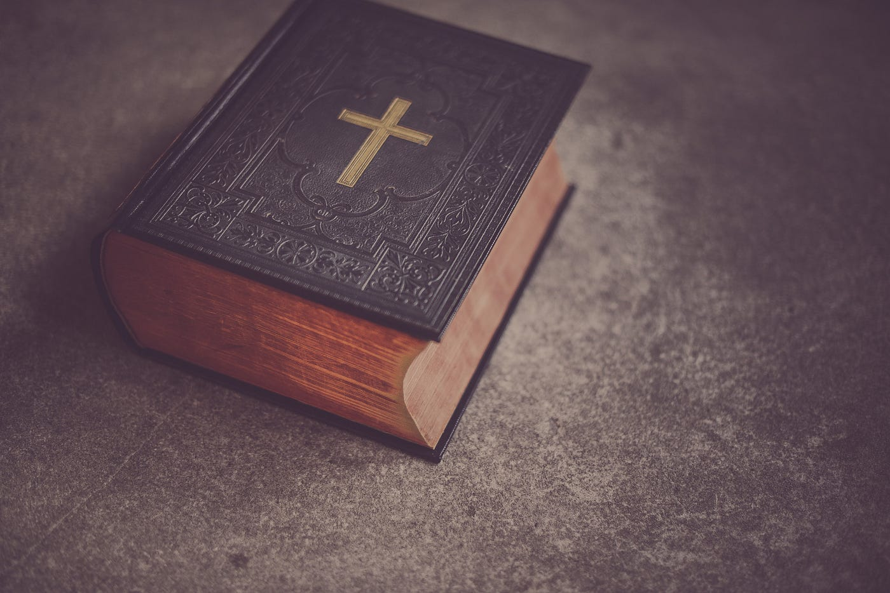

I have a colleague who always begins communion by saying, “We have been given the gift of a story.” I always found that such an appealing opening, partly because—to me—a story never really ends, it just keeps unfurling. Affirming that we have been given the gift of a story also implies to me that we are invited to participate in that story.

Listening to Bill Abriel share his spiritual journey yesterday, I could feel again the gift of story. How wonderful to learn about the Iroquois Nation and Bill’s contacts with Iroquois people. How wonderful to feel his awe at the universe, whether through physics, astronomy, or geology. Listening, I had a deepening appreciation of how science and spirituality can interact and open onto discovery. Thank you, Bill.

The Bible, too, is a story—many stories, actually—some of them pretty tangled and contradictory. Not all elements of that story make sense to us or show humans in a flattering light. Yet the Bible is a book that has survived and thrived through countless generations. In my recent sermon explorations of “basic” Christianity, I’ve looked at prayer and the commandment to love God and neighbor. In this coming week, I’m going to take on the Bible as a central record and channel of our conversation with God. (Do I dare?)

Well, all sermons are really just the start of much longer conversations, so I’ll be eager to hear your views as we explore the gift of this scriptural story together, remembering always that God is still speaking.

In Faith,

Elizabeth

Announcements

We still need someone to provide refreshments on October 8! If you can serve in this way, thank you! Drop Anna an email at orindachurch@gmail.com

**

Let’s get creative! We need lots and lots of donations for the auction so we can build our church budget. What can you offer? Meals? Vacation homes? Yummy baked goods? Gift certificates? Services? The annual auction is a great means of bringing the church together to celebrate our community and to invest in its financial health. If you have something to contribute (and of course you do), we will be collecting donation descriptions soon, for our online auction starting October 31 and culminating at a post-church party on November 5.

