Reflection for Monday,
August 14, 2023

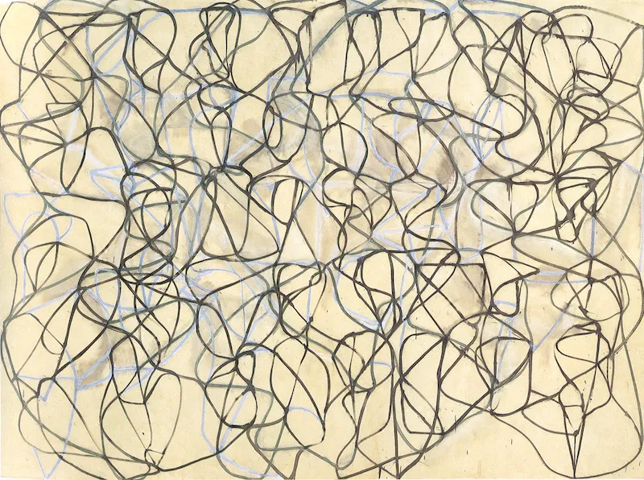

painting by Brice Marden

When I first began to work on getting unhoused people into housing, I met with a case manager who explained the Housing First philosophy to me. Every person, she said, deserves a safe, permanent home, and we don’t require that they be employed, sober, or stable in order to have that.

I asked: What about the people who have trouble staying housed? What about the people who get an apartment and then lose it?

She responded that we then get to work in housing them again. And again. And again, if necessary, until it sticks and they become comfortable and can sustain the housing.

I had colleagues who didn’t like or agree with this process. They thought it wasn’t efficient and, especially, that some people simply couldn’t be housed. That some people would mess up their housing every time and get evicted. That it was impossible to house some people. Impossible.

Impossible? What I learned is that God does the impossible all the time, but perhaps not as efficiently as we humans would prefer. I learned that I could never predict which person was ready to be housed, which person would take the risk and open their life up to healing and hope.

And if there was failure? Well, then we would try again, because every success is an enactment of the impossible. On my desk I had taped a page from a “quote-a-day” calendar:

“Miracles do happen, but you have to work hard for them.

As we push our way through the obstacles and constrictions of the merely possible, please remember that God is waiting, holding out the gift of impossible. I am praying that we keep moving toward it, recognizing what we have never completely experienced before: this impossible gift of wholeness and love.

In faith,
Elizabeth

