Reflection for Monday, May 22, 2023

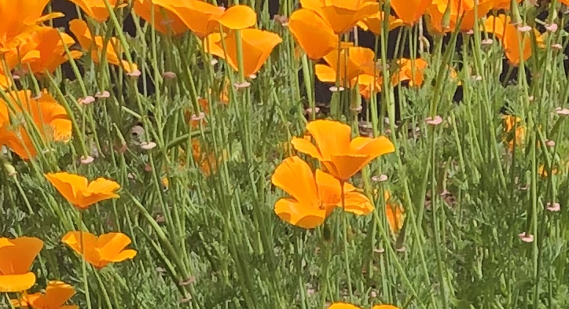

Lazy Sunday afternoon. From the other side of the raised railway tracks, I hear the pleasing ting of a ball hitting an aluminum bat. Doves visit the backyard, cooing, but when a squirrel gets too near the birdfeeder, Pinnie intervenes.

Then she lays down on the gravel, and I brush her. She accepts this as her due. If I pause, she lifts her head to look at me. Occasionally she lifts her head to sniff her fur as it clings to the brush. Why do dogs do this?

The backyard is a site of pleasure. When we moved into our house about a year and a half ago, the was a soccer net, some scruffy dirt and three trees: a meyer lemon, a persimmon, and a calamansi (also known as filipino lime). Now a small fig tree is also leafing out, a mallow is covered in pink blooms, our hellebores just keep producing more flowers, and the buddleia is bursting with purple cones.

We’ve been here long enough to have some of our planting experiments die. A fuzzy vine transplanted from Oakland did not like Pinole’s summer heat. The most beautiful blue salvia was drowned in the rains. One day I came into the backyard to find Pinnie with a newly planted gilia hanging casually from her mouth.

Now, with mounds of flowers celebrating springtime, I have taken to weeding, and here’s another garden discovery: some plants may die, but others will re-seed. The California poppies reproduce in an almost frenzied way, but I accidentally pulled up some other poppies before realizing that they had returned from last year. the Batchelor’s Buttons thankfully escaped my notice and are now blossoming, but I mistakenly yanked out some milkweed.

I put all of this, even the mistakes, down to the pleasure of living in a place long enough to learn that change is a part of continuity. The plants may seem to die, but they have dropped their seeds and will return. I see signs that a small golden forest of sunflowers is on the way. My garden is demonstrating exactly what Mimi said in her reflection today: that to be in the image of God means to live into God’s intentions, to be who you are even as you are changing. (Thank you, Mimi!)

I’m sharing with you this important information, thanks to Mimi and my garden: continuity and change can co-exist and even be an expression of God’s presence. Things die because of too much sun or too much rain or because an errant dog dug them up in order to bury a tennis ball. But look to the extraneous, the weeds, the unexpected sprouts for grow that does belong, but which you didn’t expect.

In faith,

Elizabeth

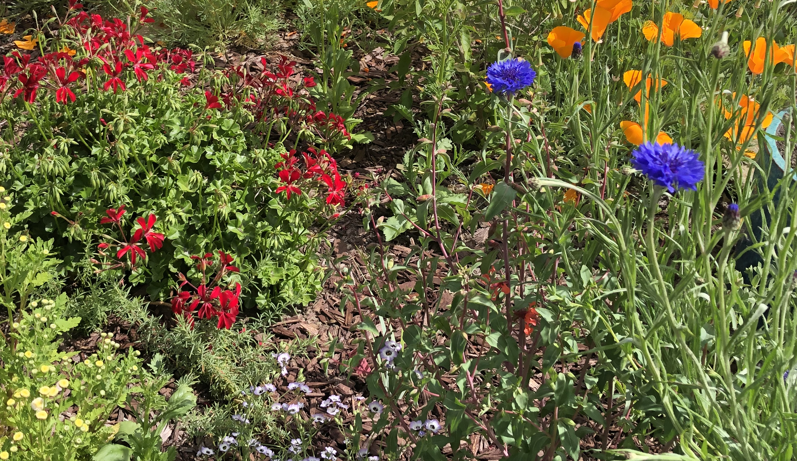

Save these dates!

Join us for a work day at The Good Table on Saturday May 27, from 12-3

*
For Second Hour on June 4th, we are honored to have Sie Savage Chambers join us to share his journey as a transgender man.
*
Fred Matteson and Anne Barr will lead Second Hour on June 11 in the Fireside Room and tell about their travels in Israel, Jordan, and other parts of the Middle East.

