Reflection for Monday, May 15, 2023

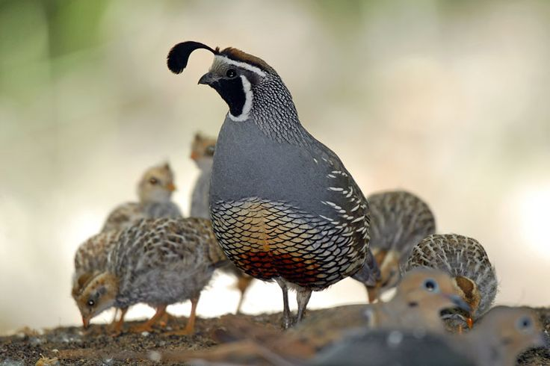

When I am feeling down about the state of the world, I like to go out to my garden, or commune with my dog. This has been true for a long time: after the attacks on the World Trade Center in 2001, I remember going to the Berkeley Botanical Garden and feeling some of the sadness and anxiety lifting off me. All around me things were oblivious to the distress of world events: a small family of quail trundled across the path, salamanders slid into a pond, branches lolled on the wind.
And I thought, “This is the innocent world.”

What is innocence? The definition of the word is “free from guilt or blame,” but that doesn’t seem quite enough to capture what I feel when I think of innocence. Another definition is that innocence is purity. This is somehow closer to how I experience innocence—not the absence of something (guilt or blame), but the active presence of a kind of wholeness and rightness. Innocence is the way my son Jonah used to dance with wild abandon when he was a kid, or the unfeigned eagerness of my husband Randy when he is given a gift that surprises him with pleasure, “I love it!”

Our culture talks about “lost innocence” as if it is a quality that you can never regain once you have lost it. But I wonder. Maybe innocence is something that we can cultivate. Paul tells the Romans, “I want you to be wise in what is good and innocent in what is evil.” Paul is indicating that we can choose innocence and goodness. This may prove a challenge in our convulsing world, but innocence, if we just turn towards it, beguiles us to be embraced by the good. On Sunday, I was moved by this simplicity—for example, by child who loves that his mother walks him to school every day.

This is a paean to innocence as a work of holiness. Becoming wise in what is good may even be a pleasure and a relief. Innocence may be the simplicity that lifts us out of the snarls of the world and welcomes us to sit side by side in pleasure with the flowers, the blue skies, and with each other.

In faith,
Elizabeth

