Reflection for Monday, March 27, 2023

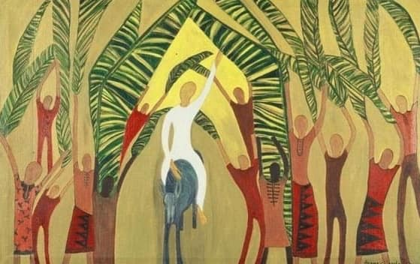
Artist unknown

Palm Sunday is always a perplexing moment in the church year for me. Jesus enters Jerusalem in a rare moment of public adulation; people wave palm fronds and even throw down their cloaks for his donkey to walk over. I have trouble resting in that jubilant moment: I jump forward to the week to come.

What could this experience have been like for Jesus himself? He had walked with some of these people through miraculous healings, enigmatic teachings, and also through their grave misconceptions about his role as a political messiah. And yet here he was, entering the center of Judaism in contentment and sunshine.

I have come to the conclusion that Jesus was deliberately going the wrong way—heading into a public conflict that would reveal the kinds of spiritual and ethical conflicts that hold us humans captive.

This quote from Rebecca Solnit seems pertinent here:

I love going out of my way, beyond what I know, and finding my way back a few extra miles, by another trail, with a compass that argues with the map… I have lost myself though I know where I am. Moments when I say to myself…I have never seen this place before. Times when some [detail] that has escaped me these many years says to me that I never did know where I was, even when I was home.

This coming week, we follow Jesus through, so to speak, the back door of Jerusalem. There, he teaches us to see our faith as we have not seen it before. There, we will celebrate with him because he is in some deep sense bringing us home to a truer faith. And there we will pause to realize that our faith is a distinct and perhaps strange sanctuary. A home indeed—but one that challenges and changes us, finally guiding us to who and where we are.

I am grateful to make this journey with you.

In faith,
Elizabeth

Join us next Sunday after the service for a time of music and meditation in the fellowship hall. We will enter into Holy Week with a Palm Sunday time of walking the labyrinth—or you may just wish to sit and listen to Judy McCall play her cello for us.

Please let us know by March 31 if you plan to join us for our April 5 Seder dinner! We are so excited to have Sarah Elovich leading us through this important Passover tradition. Contact Anna in the office to let us know if you will be attending. $20 donation requested, as you are able.

