Reflection for Monday,
March 11, 2024

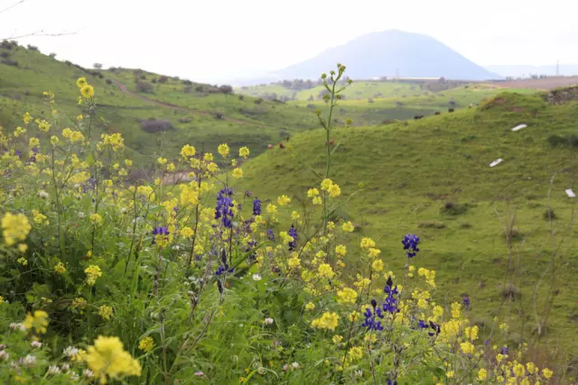

I was thinking about Lent as a wintry season—cold and somber, with the purplish hues of a winter sunset. In such a season it would be an easy time to curl up in contemplation, right?

But as we’ve emerged from the recent rains, the salvia is blooming, tulips I forgot I’d planted are showing their pink faces, and I realize that all this time the soil has been sending up green messages that are now beginning to blossom.

Lately it’s occurred to me that Jesus, wandering alone in the wilderness, was not as desolate and solitary as I might have thought. He found what he needed to survive in human terms—remember those locusts and the honey! And surely he couldn’t help but feel, see, scent, and yes, taste the changes in the landscape around him. Fields of red poppies, lupine, fig trees leafing out.

What does it mean that spring comes in Lent, before Holy Week, before Easter itself? If nature’s regeneration comes to us as communication from God, then I think the message is that we need to be seeking life even in our most somber, critical seasons.

O taste and see. A sapsucker is drilling orderly holes in the branches of the pepper tree that overhangs our back fence. On the way home from church, I see the glossy coat of a coyote as it trots into underbrush. A hawk perches on a fence post aware of movement that I can’t see. And a trio of turkeys graze peaceably in a field with a horse.

Lent includes all this: the bee resting on my pant leg as much as the deluge that is pouring down the slope. Holy balance is asserting itself all around us. May our Lenten practice be to notice life waking up all around us.

In faith,
Elizabeth

