Reflection for Monday,
January 8, 2023

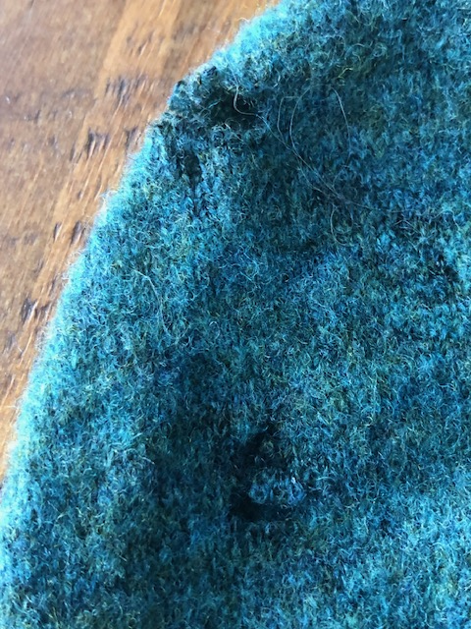

While my son Jonah was visiting over Christmas, I took my favorite sweater out of the closet and showed it to him. Jonah has mad sewing skills, so I thought maybe he could help me.

“Jonah, can you maybe help me sew up these holey bits where moths ate into my sweater?”

Jonah looked and then said, “Oh, I remember that sweater. You used to wear it all the time. But, no, the way it is frayed will make it hard to sew up. Mom, it’s still beautiful. You should just go ahead and wear it with the holes.”

Now, I may not be much for sewing, but I can make a metaphor out of anything. Yup, I am wearing my frayed sweater and, I suppose, I am broadcasting those elements of my self that are frayed. I recently began reading a book by Charlie Porter, Bring No Clothes, that examines the import of clothing for early British modernists (like, for example, Virginia Woolf). He, too, sees clothing as a metaphor, noting the ways that 19th century clothing could be formal and restrictive and could tightly code for class and privilege.

So as we enter the new year, perhaps not as refreshed as we’d like to be—catching up with after-holiday tasks, grieving over war—let’s permit our worn elements to be what they are, expressions of our lives. As Charlie Porter notes, how we dress (and I’ll extrapolate to say how we wear ourselves) is linked to all the meanings and affiliations in our lives. A thing can be beautiful and imperfect, special and practical all at the same time.

It's God’s grace that helps us to recognize this in ourselves and in our community life together: somehow, everything comes together to make God’s whole. So expect to see me at the church wearing my green hooded sweater. I’ll be glad to show you the holes where the moths enjoyed it too.

In faith,
Elizabeth

Notes for this week:

Theology and Scripture will NOT be meeting this week and will resume on Thursday, January 18 at 2:00. We are beginning a new book, Decolonizing Palestine, by Mitri Raheb, and will discuss the first chapter. All are welcome!

Elizabeth will be away next weekend, giving a poetry reading in New York. We are delighted to have the Rev. Erin King as a guest preacher. PLEASE stay after the service—first for a short budget meeting, and then for lunch, followed by a concert by Lukas Veseley. We are so fortunate to have him sharing his music with us! Feel free to invite friends.

