Reflection for Monday, December 4, 2023

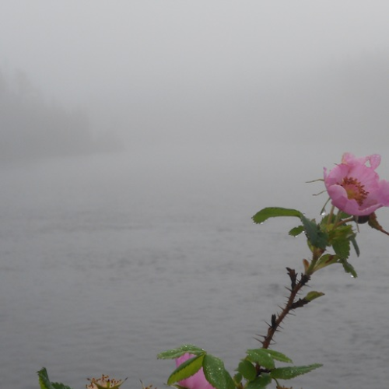
Photo by Tara Moreau

I don’t have much to say for myself today because I am still recovering from the powerful bug that swept through my body. But as we are entering the second week of advent, I will claim peace as the sensation that comes over the body as it regains its equilibrium. After twenty-four hours of notable discomfort, I just feel tired. Looking out the bedroom window, I see everything held in a thick fog that makes all boundaries vague and fuzzy. A few pink mallow blossoms rise up in the frame of the window.

In my lassitude, I am calling upon the many promises of peace in our scripture. Consider John 14: 27:
Peace I leave with you; my peace I give you. I do not give to you as the world gives. Do not let your hearts be troubled and do not be afraid.
May peace bring us the many forms of healing and insight that we need—personal, global, spiritual, political.

In faith,
Elizabeth

