Reflection for Monday
January 15, 2024

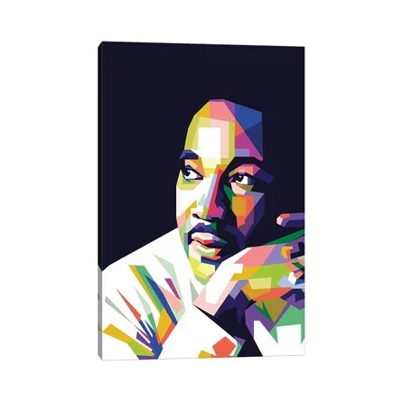art by Dayat Banggai

How timely that we are celebrating the legacy of Martin Luther King, Jr. as we navigate an especially fraught and painful moment in global conflict.

It is meaningful to me that King’s civil rights work was always conducted through the lens of his calling as a Christian. That doesn’t mean that King always knew exactly want to do, but that he understood his calling was larger than his individual self.

Though he was ultimately assassinated for his convictions, I see Martin Luther King, Jr. as an exemplar in the Christian calling to choose life. In the midst of differing views, choosing life seems like a good baseline for our church community.

Below, I share some words of King’s which have long been meaningful to me and have shaped my own (fundamentally pacifist) orientation:

Hate begets hate; violence begets violence; toughness begets a greater toughness. We must meet the forces of hate with the power of love... Our aim must never be to defeat or humiliate [opponents], but to win their friendship and understanding.
The ultimate weakness of violence is that it is a descending spiral begetting the very thing it seeks to destroy, instead of diminishing evil, it multiplies it. Through violence you may murder the liar, but you cannot murder the lie, nor establish the truth. Through violence you may murder the hater, but you do not murder hate. In fact, violence merely increases hate. Returning violence for violence multiplies violence, adding deeper darkness to a night already devoid of stars. Darkness cannot drive out darkness; only light can do that. Hate cannot drive out hate; only love can do that.

May you all have a meaningful Monday holiday. I strongly recommend watching the film “Rustin,” about a friend and colleague of King’s (it’s available on Netflix). Perhaps that would be a good way to deepen your sense of this holiday! I look forward to seeing you on January 21st for our annual meeting.
Please note that the church office is closed on Monday for the holiday.

In faith,
Elizabeth

