Reflection for Monday, October 2, 2023

Perhaps you, too, have experienced the invasive energies of bindweed. It snuck into the soil near our rosebush and twined around the roses. It has poked through the gravel near our birdbath, and reproduces quickly beneath our lemon tree. I had been told that you shouldn’t just pull it up because the roots remain underground and will continue to grow. Sigh.

But then Randy did some reading and learned some helpful facts. Yes, bindweed has a network of roots, but if you persistently pull up sprouts, eventually the plant will die, especially if it can’t mature enough to produce the leaves that capture sunlight. Also, bindweed thrives in poor soil, so when you hoe and add good soil and plant the flowers and shrubs you actually want in your garden, the bindweed won’t be as vigorous and will eventually fade away.

Doesn’t this sound like a parable? First there’s the encouragement to just keep plugging, pulling up the weeds, or persisting through problems—with an assurance that you can outlast the difficulty. And then the even more appealing option of enriching the soil and planting beautiful things: basically, we should just nurture the garden that we really want, full of color and fruit and shade—and the weeds will disappear.

After a tiring summer, I’m happy to take adopt this both as a gardening practice and spiritual advice. The yucky stuff will go away if we keep pulling it up and tossing it out. And richness and fertility will abound if that’s where we put our attention and effort. God speaks to us in every moment of our being, even in bindweed.

In faith,
Elizabeth

Announcements

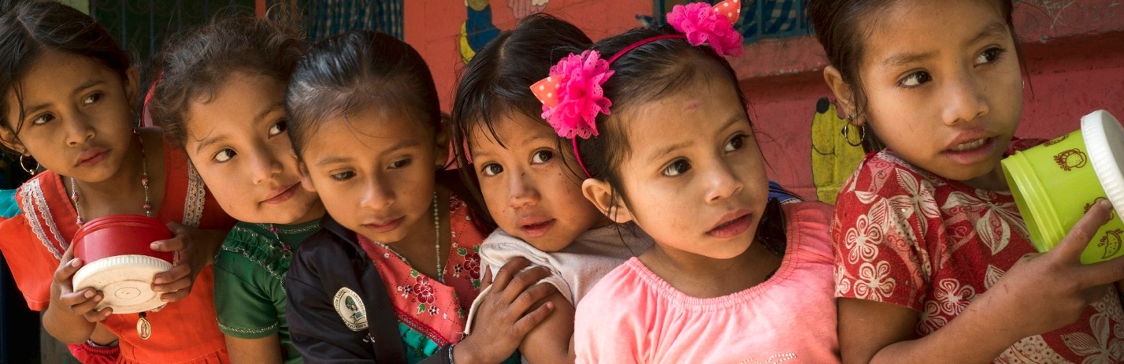
Hello from Mercy and Justice:

It is that time of year when we raise money to support our commitment to Common Hope in Guatemala.

We have pledged to raise, yearly, enough money to help Common Hope build a house for one of their participating families.

The “Help Build a House” board will be in the Narthex after church staring October 8, 2023. I will help people with their donations after church or you can send a check to church, made out to Orinda Community Church with Common Hope House in the memo line.

We need to raise $800 from the congregation to add to the $1000 allocated from the Mercy and Justice budget for this purpose.

If you don’t know about Common Hope and want to know more check out the website at CommonHope.org. The Common Hope second hour at church will be on October 22, 2023, led by Roger Samuelsen who has worked with Common Hope for many years. Please plan to come and learn about other ways to help the Common Hope families.

Thank you so much,
Karen Sanford

