Reflection for Monday,
March 18, 2024

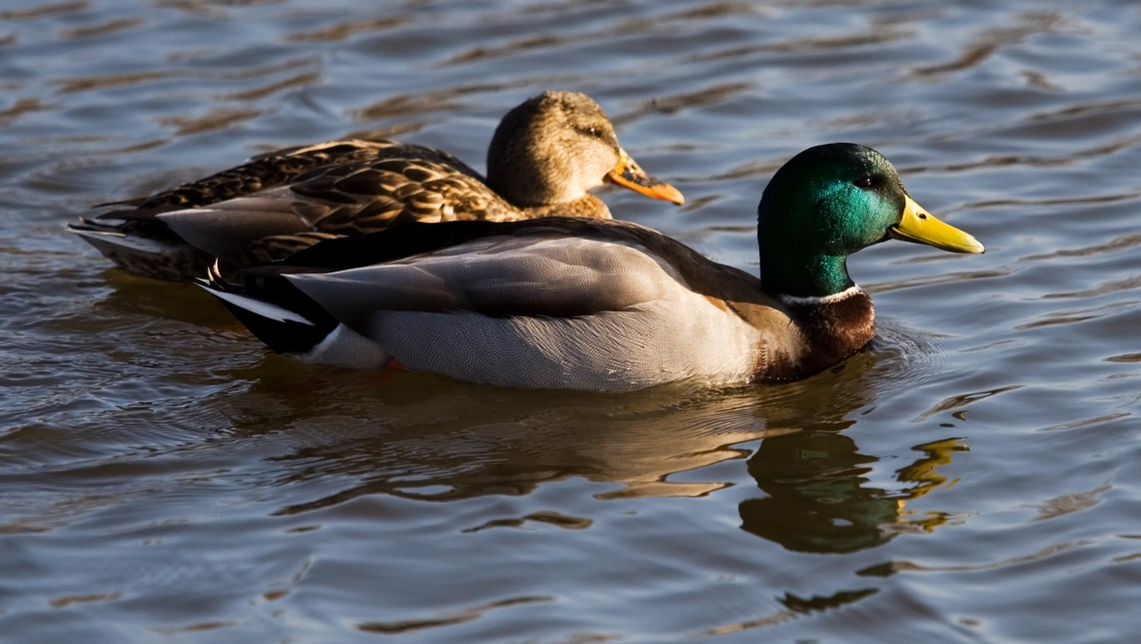

(a reflection pulled from my sermon this week)

What if glory soaks into us from the ground up, from our grassroots efforts, our mostly unseen support and advocacy for other humans, habitats, justice practices? The flower is beautiful; when it withers and its seeds fall into the ground, that appears far less glamorous. But the seed transforms itself into new life and, in doing so, transforms the soil around it. Glory is a homely garden growing. Nothing spectacular—unless you are the bees and birds and skunks and squirrels and humans who will be fed by it.

Jesus is reorienting us as Jesus always does. And Jesus’s version of glory has all the beauty of the clouds shedding their radiant light, and at the same time, glory is the solid ground beneath our feet and the good gravity that holds us here. It is a path on which we can find our way.

I was beginning to get confused by all this talk of glory, so I took a break and went on a walk. I was trying to think of glory as accessible, nourishing, a way forward in a time of crisis and much global suffering. I was trying to imagine a glory that is devoid of ego, a glory that can transform the brokenness and husks of things into purpose, love, and meaning.

As I walked, I passed through a broken path that was strewn with chunks of concrete. There were deep gouges in the mud where heavy machinery had carved into the soil. Some other walkers passed me, tsk-tsking at the mess of it. I paused, feeling the warmth of the sun soaking into my neck, a balmy breeze moving warm air up from around my ankles. Looking slightly downslope, I noticed two ducks swimming in an ersatz pond: tractor ruts filled with rainwater. It was a mallard and his mate. They quacked. They splashed. They were safe and, to all appearances, happy. Did they care that their sparkling, sunlit pond was an accident of industry? Did they care that the grasses they were eating were what you and I would call weeds? No. Before my eyes, they rediscovered the world for me, and it was glorious.

In faith,
Elizabeth

Announcements

Please join us after the service next Sunday for a light lunch and to make birds as part of our Palm Sunday peace vigil. We will meet in the fellowship hall.

