Reflection for Monday,
January 2, 2023

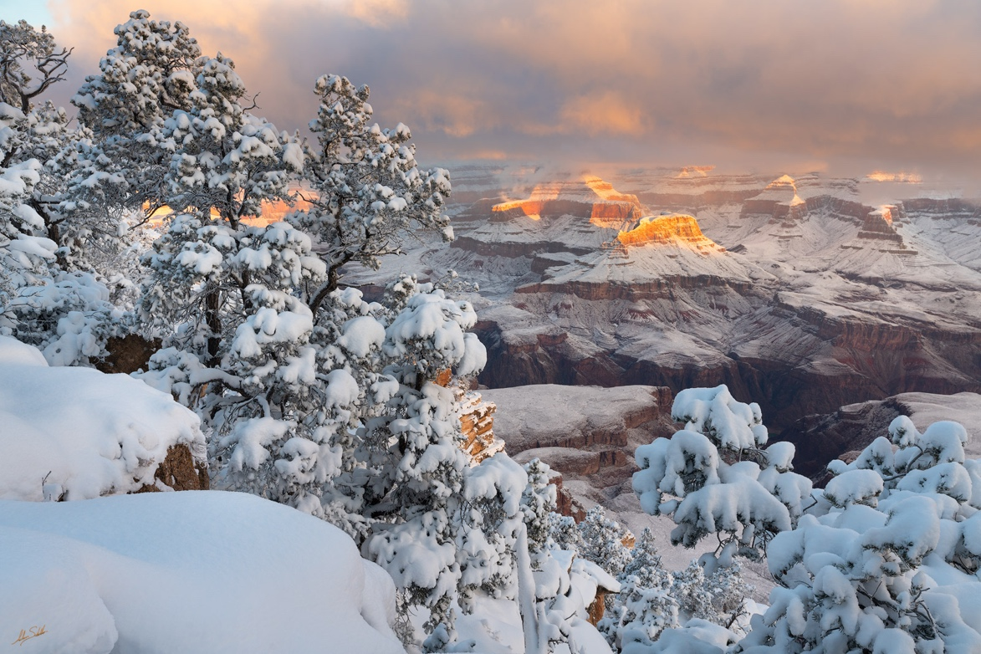

photograph by Adam Schallau

Happy 2023!
To invite in the new year, I’m delighted to be able to share this poem
by Laurel Reader-Taatjes.

Hope In Winter’s Light
Somewhere
Snow is falling
It drifts down in sheets of white
That cling to tree branches
And settle on the once green ground
But we don’t see that
Somewhere
People are crying
Tears of joy and tears of sorrow
That stain the world
With darkest grief in tears that never stop
Someone is crying
But we don’t see that
Somewhere nearby
A bird sings a song
Maybe we hear it
Maybe we don’t
Somewhere nearby
A faint light flickers
Somewhere in coldness
Somewhere in sun
If we think of life
As darkness and light
Darkness is grief
Light is our hope
Somewhere
Hope is a candle
Burning hot and bright
That hope is almost
Tangible
Like heat
Against a wall of ice
Somewhere
Hope is a thread
Shining with bioluminescence
That hope is
Barely there
But there all the same
Like light
On the walls of a cave
Hope is not always bright
It’s not always
A flame in the darkness
A lantern guiding you on
Sometimes hope is the moon
Sometime hope can be seen
As a winter sunbeam through clouds
Sometimes hope is the sparkle in our eyes
When we see someone we love
Or light from a screen
Reflecting silver off ornaments
Hope isn’t always something radiant
Something obvious
The best type of hope
Is the type that comes to you
In the form you least expect it.

