Reflection for Monday, July 3, 2023

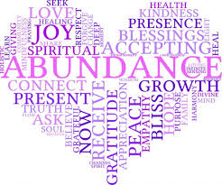

I’ve begun reading Matthew Desmond’s book, Poverty, By America. I encourage you to read it as well because I think we will have some important conversations as a result.

Desmond says that it is not enough to examine the conditions of people in our country who are living in poverty. Rather, we need to ask why “the richest country on earth [has] more poverty than any other advanced democracy.” Desmond goes on to demonstrate the ways that our society structurally thwarts movements out of poverty even when doing so is costly and damaging for all of us.

I was reminded, as I read this, of a recent public radio story about how difficult it is for individuals applying for disability income. Research has brought to light that case management staff that process applications has declined, slowing individuals’ ability to access benefits. At the same time, staff screening for recertification or cessation of benefits has seen enhanced funding. The emphasis is therefore clearly on limiting access to financial support, even for people who have legitimate needs.

As I was writing this, my husband shared a headline with me “Los Angeles Unhoused Population Reaches 70,000.”

To address this vast poverty and suffering, Matthew Desmond says that we will all need to become “poverty abolitionists.” I agree! And it’s going to take determination and creativity to do so.

How do we make sure that the promise articulated in Matthew 7:7 is true?

Ask, and it will be given to you; seek, and you will find; knock, and it will be opened to you.

As we celebrate our nation’s independence, can we also celebrate our interdependence? We, who live in material abundance—let us come together and share our faith, our hope, and our resources not just to address immediate need, but to create systems of generosity and equality for all.

In faith,

Elizabeth

