Reflection for Monday, May 1, 2023

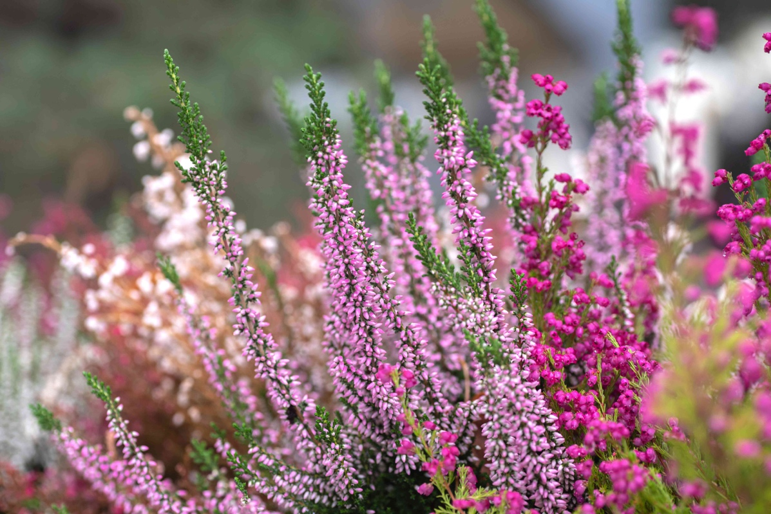

Thank you all for your kindness and support in the aftermath of my sister Gail’s death. I am grateful for her life and that she lived long enough to see her youngest daughter launched very successfully at the University of Edinburgh and all three of her cherished children doing well. I am grateful for your generosity and support because I know, in so many instances, it is informed by your own experiences of loss. You are a blessing in my life.

While I was at my mother’s house this last week and a half, I took breaks from doing practical tasks to work in her yard which is green and plush, but rather unruly after this year’s rains. It was a great relief to pull out weeds and cut boundaries between shrubs that had become enmeshed with each other. I guess you could say that our grief work is, in part, trying to bring some order to the tangle of our feelings. Seeing the salvia that emerged when I yanked out long strands of grass helped me to feel that the world was just a little less chaotic.

But the salvia itself was overgrown, branching out every which way. I sat down in front of it and began to prune, using the method that my sister-in-law Linda taught me long ago: start at the base, and cut out all the down-branching twigs, the dead bits, the parts that overlap and obscure each other. Her advice? Make sure the air can get in there and breathe with the plant. Cutting away, I could see the architecture of the plant revealing itself—no longer fragile knots of branches, but a mature plant that, beneath all the excess, emerged as having a beautiful fan shape.

I’m going to adopt this as a metaphor. Underneath all the sadness and confusion that comes with a death, there is a sturdy structure, a life we love and value. It may look bare, even bereft, when it is pruned back to its rudiments, but the spirit breathes around it; it will grow and flower again, nourished by our memories and all the mysterious ways life, even if in ways we can’t really understand, continues. A blessing on the life of my sister, Gail, and on all those whom you have lost but continue to love.

In faith,
Elizabeth

**

In June of this year, we will celebrate Pride Month in a number of ways. As we move into spring, please be aware that there are also resources and events in our conference that give us opportunity to learn and become allies.

You are invited to join the Northern California Nevada Conference Queer and Trans Solidarity Action Day on Saturday, May 20th from 10-3, which will be conducted over Zoom.
If you would like to participate, you can register here:

https://ncncucc.my.salesforce-sites.com/default/CnP_PaaS_EVT__ExternalRegistrationPage?event_id=a2CEZ00000007uG2AQ

