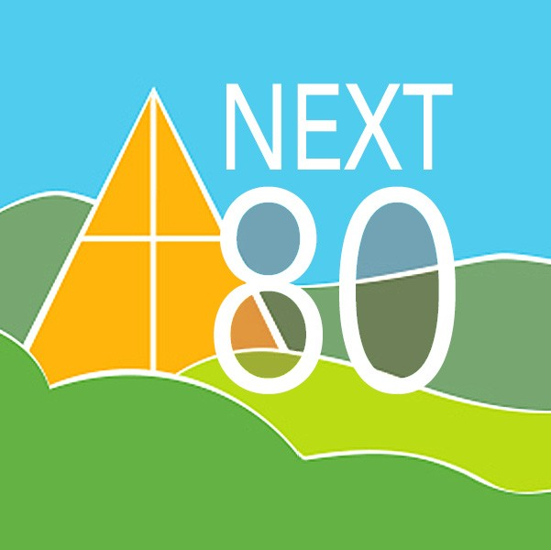
OUR NEXT 80 YEARS: ENSURING ORINDA COMMUNITY CHURCH’s PLACE IN THE FUTURE OF OUR COMMUNITY

Background:
To ensure our place as Orinda’s Community Church, Church Council and our Endowment Board sponsored a new capital campaign in June of 2021 to fund important and urgent church campus improvements. Because of favorable market returns in the endowment fund over the previous year, the Endowment Board generously committed to a matching fund grant of up to $100,000 to jump start this effort. Every donation made by the congregation was matched by the Endowment Board, up to a total of $100,000. At that time, we estimated the cost for these improvements at $300,000, and we hoped to raise an additional $200,000 over the Endowment Board’s contribution from church members through pledges paid out over three years.

Results:
Through the generosity of all of you, 40 members contributed 25 pledges totaling $293,367, meeting our match goal with the Endowment Board, who then contributed their promised $100,000, for a total campaign raise of $393,367. So far, we have received $202,867 of the pledged donations (remember that they are scheduled to be paid over three years) and the $100,000 endowment fund donation for a total of $302,867. We anticipate the remaining $90,500 to be paid over the next 18 months.

Status:

Through the first year of the Next 80 program, we have approved and spent $81,660 on the following projects:

- $52,900 - Painting of exterior of Washington/Mayflower building, Agape building,
Holden School, Music Room and corridor including ceiling, trim and
windows around lower front and side of Sanctuary.
- $ 3,035 - Replacement of 2 windows with dry rot in Mayflower room
- $18,706- Carpeting and interior painting in Narthex and Sanctuary
- $ 4,962 - Sanctuary lighting
- $ 2,057 - Preliminary seismic consultation

Next Steps:

As you might imagine with a campus over 60 years old, the list of possible uses of our remaining funds is quite long! Some of the items on our current planning list for this year (year two of the program) are:

- Seismic study to ensure that our structures remain safe for all who use our facilities – bid received but due to cost, we are looking at our options
- Sealing work along balcony at edge of Sanctuary and other roof repairs to stop and prevent water damage – bid being revised
- Window retrofit at TOPS – Given the increase in severity of our fire season, and the effect smoke has on the children at TOPS, we will be replacing the louvered windows in their space with more energy efficient and sealable windows. Bid received (This is also a problem for other areas on our campus where we have old louvered windows, and the costs and timing will be discussed by the committee.)
- Drainage in lower lawn area - bid received
- Campus lighting fixtures retro fit or replacement – under discussion
- Exterior Sanctuary painting and rehab – bids received, but due to cost, we are reconsidering approach
- Landscaping and irrigation following removal of junipers along Irwin Way (junipers must be removed per Fire Department regulation) – under discussion and likely to be funded

We have purposely not pursued additional items on our list until we understand the costs of the seismic study and any rehabilitation needed as those costs are likely to be high. We are also deferring the rest of the sanctuary painting until the patches and repairs are made so that we don’t end up with water damage on our new surfaces.

Thank you from the committee members for your continuing commitment to this important work. If you would like to participate in the committee or can volunteer your time to help oversee any of the projects that Next 80 funds, please reach out to the church office.

Respectfully submitted,

Fred Matteson, Gail Mead, Lani Shepp, Mike Kersten, Karen Sanford, Tom Norris, Bob Winbigler, Andy Webber, and Peter Hartdegen

