Orinda Community Church
An Open and Affirming Congregation of the United Church of Christ
Reverend Elizabeth Robinson, Senior Pastor

Order of Worship
Sunday, April 14, 2024, 10 am

Fish made with recycled plastic bottles

Reflection

Action on behalf of life transforms. Because the relationship between self and the world is reciprocal, it is not a question of first getting enlightened or saved and then acting. As we work to heal the earth, the earth heals us.
― Robin Wall Kimmerer

WE GATHER

PRELUDE

BRINGING OF THE LIGHT & RINGING OF THE HOUR The Acolytes

INTROIT Communion Medley Chancel Bellringers

WELCOME Reverend Elizabeth Robinson

CALL TO WORSHIP* Gail Mead

One: Let us pray for an end to the waste and desecration of God's creation.

All: For access to the fruits of creation to be shared equally among all people and for communities and nations to find sustenance in the fruits of the earth and the water God has given us.

One: Creative and Loving God, you created the world and gave it into our care so that, in obedience to you, we can serve all people.

All: Inspire us to use the riches of creation with wisdom, and to ensure that their blessings are shared by all; that, trusting in your bounty, all people may be empowered to seek freedom from poverty, famine, and oppression.

HYMN* RH 64 Holy. Holy, Holy! DYKES 1861

COMMUNITY PRAYER by Walter Rauschenbusch Gail Mead

O God, we thank you for this earth, our home;
For the wide sky and the blessed sun,
For the salt sea and the running water,
For the everlasting hills
And the never-resting winds,
For trees and the common grass underfoot.
We thank you for our senses
By which we hear the songs of birds,
And see the splendor of the summer fields,
And taste of the autumn fruits,
And rejoice in the feel of the snow,
And smell the breath of the spring.
Grant us a heart wide open to all this beauty;
And save our souls from being so blind
That we pass unseeing
When even the common thorn bush
Is aflame with your glory,
O God our creator,
Who lives and reigns forever and ever.

WORD OF ASSURANCE Reverend Elizabeth Robinson

Pastor: The peace of Christ be with you.
People: And also with you.

WE LISTEN

SCRIPTURE READING Gail Mead

Luke 16:19-31

There was a rich man who was dressed in purple and fine linen and who feasted sumptuously every day. And at his gate lay a poor man name Lazarus, covered with sores, who longed to satisfy his hunger with what fell from the rich man’s table; even the dogs would come and lick his sores. The poor man died and was carried away by the angels to be with Abraham. The rich man also died and was buried. In Hades, where he was being tormented, he looked up and saw Abraham far away with Lazarus by this side. He called out, “Father Abraham, have mercy on me, and send Lazarus to dip the tip of his finger in water and cool my tongue; for I am in agony in these flames.” But Abraham said, “Child, remember that during your lifetime you received your good things, and Lazarus in like manner evil things; but now he is comforted here, and you are in agony. Besides all this, between you and us a great chasm has been fixed, so that those who might want to pass from here to you cannot do so, and no one can cross from there to us.” He said, “Then, father, I beg you to send him to my father’s house—for I have five brothers—that he may warn them so that they will not also come into this place of torment.” Abraham replied, “They have Moses and the prophets; they should listen to them.” He said, “No, father Abraham; but if someone goes to them from the dead, they will repent.” He said to him, “If they do not listen to Moses and the prophets, neither will they be convinced even if someone rises from the dead.”

SERMON Clean Up Your Plate Reverend Pam Abbey

WE RESPOND

HYMN* RH 182 Word of God, Come Down on Earth ABLE 1664

A TIME OF PRAYER

JOYS AND CONCERNS PASTORAL PRAYER
OUR LORD'S PRAYER
Our God, who art in heaven, hallowed be thy name. Thy kingdom come, thy will be done on earth as it is in heaven. Give us this day our daily bread. And forgive us our debts, as we forgive our debtors. And lead us not into temptation, but deliver us from evil. For thine is the kingdom, and the power, and the glory, forever. Amen.

MOMENT FOR ANNOUNCEMENTS

OFFERTORY SOLO

DOXOLOGY RH 94 LASST UNS ERFREUEN

Praise God from whom all blessings flow;

Praise God, all creatures here below;

Alleluia! Alleluia!
Praise God for all that love has done;
Creator, Christ, and Spirit, One.
Alleluia! Alleluia!

HYMN* RH 393 Spirit of the Living God IVERSON 1926

BENEDICTION* Reverend Elizabeth Robinson

Orinda Community Church
10 Irwin Way, Orinda CA 94563
(925)254-4906
office@orindachurch.org

Reverend Elizabeth Robinson, Senior Pastor
David Milnes, Director of Music
Anna Gregory, Office Administrator

WEEKLY EVENTS

In addition to 10 am Sunday worship, we offer these weekly:

- Monday mornings at 9:30 a.m. in the Chapel, we host Centering Prayer.

- Wednesday mornings at 10:00 a.m., we hold a brief Contemplative Service in the chapel, which includes readings, music, prayer time, and silence. This service also goes out electronically.

- Life and Loss Group meets every Thursday in the Fireside Room from 12:15 pm to 1:45 pm. No need to sign up. Please stop by if you are interested.

- Thursday afternoons at 2:00 p.m., our Theology and Scripture group meets via Zoom to discuss theology, the bible, and other topics. The next meeting is Thursday, April 18.

And these, every other week:

- Two Tuesdays a month, the Writers’ Group shares and discusses their writings via Zoom at 10:00 a.m. The next meeting is Tuesday, April 16.

- Two Thursdays a month, starting at 3:45 p.m., the Reading Group meets via Zoom. The room opens 15 minutes early for welcome and chatting. Our next meeting is Thursday, April 18.

Thank you to this week’s ushers:

Marilyn Welland, Jill Oberheim,
Betty Wu, and Lani Shepp

FELLOWSHIP HOUR
Volunteers are needed each week to make the coffee and bring a treat to share for the Fellowship Hour after services on Sunday.

The Ushers have the sign-up sheet.
Please sign up for a Sunday!

Today’s coffee and treats were brought to you by
Gail Mead and Lin Lyons

BLACK WEALTH BUILDERS FUND

If you are interested in contributing to this innovative program, please write “Black Wealth Builders Fund” in the memo portion of your check, and submit to an usher or to the OCC office.

Together, we can make steps to repair the decades of
discrimination that has damaged black communities.

For more information about this program, go to
https://www.arlingtoncommunitychurchucc.org/bwb

Peace Vigil

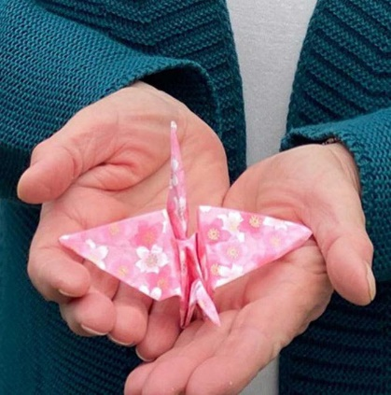

Each Thursday at 10 am, any and all are welcome to join the Peace Vigil in the church library where we make birds to recognize and cherish the beloved lives of children lost in war, especially those now dying of starvation in Palestine.

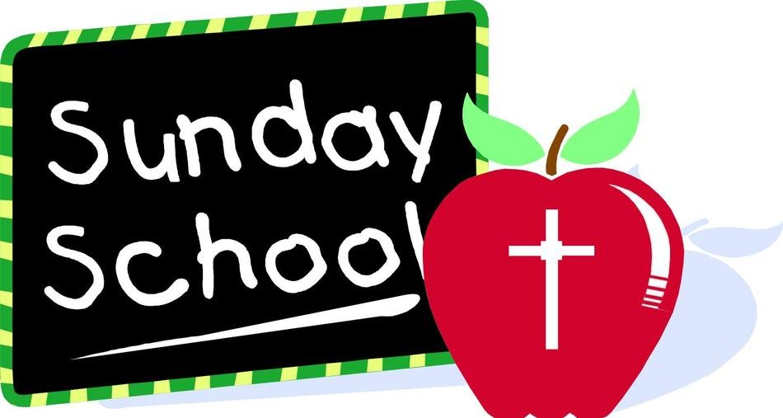

Elementary aged kids are welcome to join us in the

Agape Center each week for some learning and fun!

Kids start in the Sanctuary for Sunday service and then

are excused part way through, to go to Sunday School.

For any questions about Sunday School, or if you’d like to volunteer, please contact Amy Parlett at saparlett@comcast.net

Please keep bringing your clothing items to the church
for the Trinity Center.

They are always especially in need of men’s pants and shoes,
but will accept all clean clothes with some life left in them.
Women’s clothes are needed as well.

Contact Nancy Thursby if you have any questions: nlthursby@comcast.net

