Contemplative Service
For Wednesday, January 31, 2024

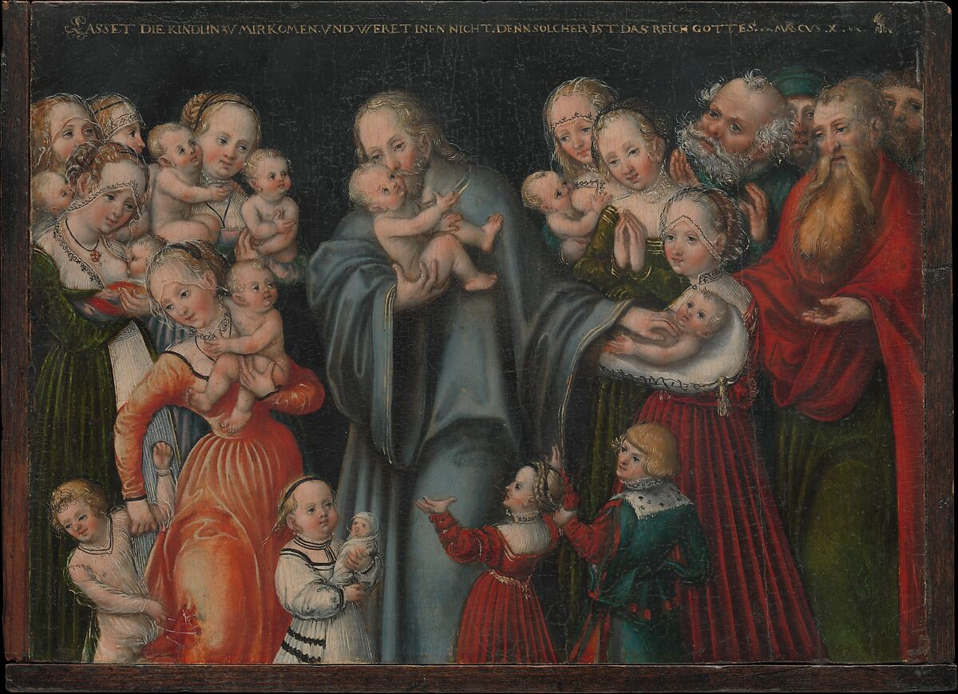
Painting by Lucas Cranach the Younger

Always we begin again.
—St. Benedict

First reading: Ecclesiastes 3:11

God has made everything beautiful in its time. The Holy One has also set eternity in the human heart; yet no one can fathom what God has done from beginning to end.

Music: Bach, Prelude 1 in C Major, BWV 846, performed by Tzvi Erez
https://www.youtube.com/watch?v=PXMVkQ70I88

Second reading: Mother Teresa of Calcutta

When you have nothing left but God, you have more than enough to start over again.

Music: Chopin, Prelude in E minor, Op. 28, No. 4, performed by Eric Lu

https://www.youtube.com/watch?v=90wBhBZjAUQ

Time of silent contemplation

Few souls understand what God would accomplish in them if they were to abandon themselves unreservedly to Godself and if they were to allow God’s grace to mold them accordingly."

—Saint Ignatius of Loyola

Communal Blessing:

Sacred Expanse,
Our limits hold us so tightly. We regret our endings before we ever arrive at them. In a world so obsessed with, and defined by loss, help us to cradle our beginnings. The start of a friendship. A green leaf in the palm. A crescent moon carving its light into the evening sky. You, whose wholeness unfolds forever and forevermore, cradle each of us as one of your beginnings. Teach us to cherish all that is tender and unfinished. Amen.

Music: Kabalevsky, Prelude No. 1 in C major, Op. 38, performed by Vladimir Horowitz
https://www.youtube.com/watch?v=qwDEsDp3qf8

May each day open a new beginning, bringing forth eagerness, clarity, and kindness.

