Contemplative Service for Wednesday,
September 27, 2023

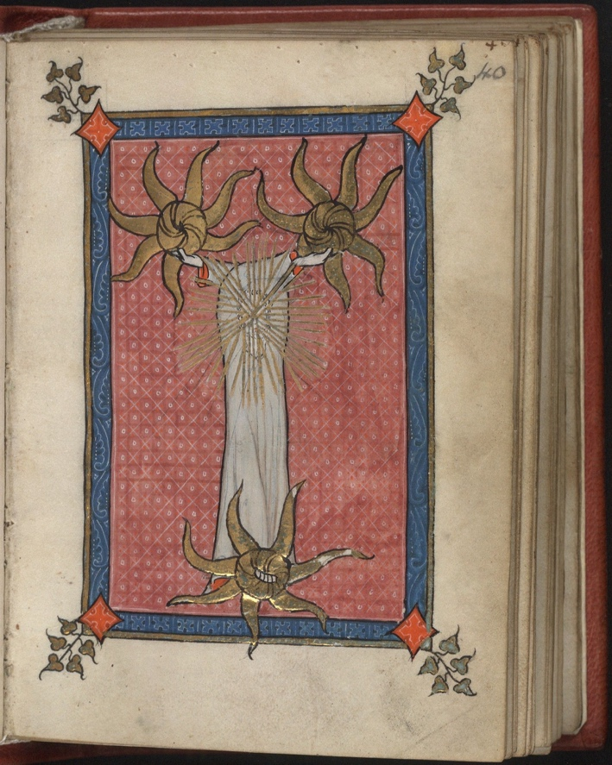

From the Trinity miniature from the Rothschild Canticles,
made in Flanders, ca. 1300.

First reading: Isaiah 55:11
So shall my word be that goes out from my mouth; it shall not return to me empty, but it shall accomplish that which I purpose, and shall succeed in the thing for which I sent it.
Music: “Simply Purple for Viola” by Joan Tower, performed by Paul Neubauer
https://www.youtube.com/watch?v=Lb8DmE8HWxI

Second reading: from the writing of Hildegard von Bingen

And so I beseech you, through the serenity of God, through the wondrous Word, through the sweet fluid of remorse, through the spirit of truth, through the sacred sound to which all creation resounds, through the Word that gave birth to the world, through the sublimity of the Father whose sweet viriditas released the Word in the Virgin’s womb, where it took on flesh like a honeycomb built out from honey: may this same sound, the power of the Holy One, descend on your heart and elevate your soul so that you do not remain idly numb to this word.

Music: “Miniatures #1” by TJ Cole, performed by Robert Simonds
https://www.youtube.com/watch?v=E14J4LiygSc

Time of Silent Contemplation

Lord, thou hast given us thy Word for a light to shine upon our path;
grant us so to meditate on that Word, and to follow its teaching,
that we may find in it the light that shines more and more until the perfect day;
through Jesus Christ our Lord.
—Jerome, c. 342 – 420

Communal Blessing
Vital Word,
Say yourself within us. We strive to respond in kind—graceful or blunt, wan or ardent, each word true to its speaker. Each prayer a new language finding its way to meaning. We will not return to you empty. Your fullness uttered and embodied in us. Amen.

Music: “Song” by Jennifer Higdon, performed by Molly Barth
https://www.youtube.com/watch?v=VHTDy-8d5Tk

May the Word find you in the world’s beauty and lyricism this week.

