Contemplative Service for Wednesday,
September 13, 2023
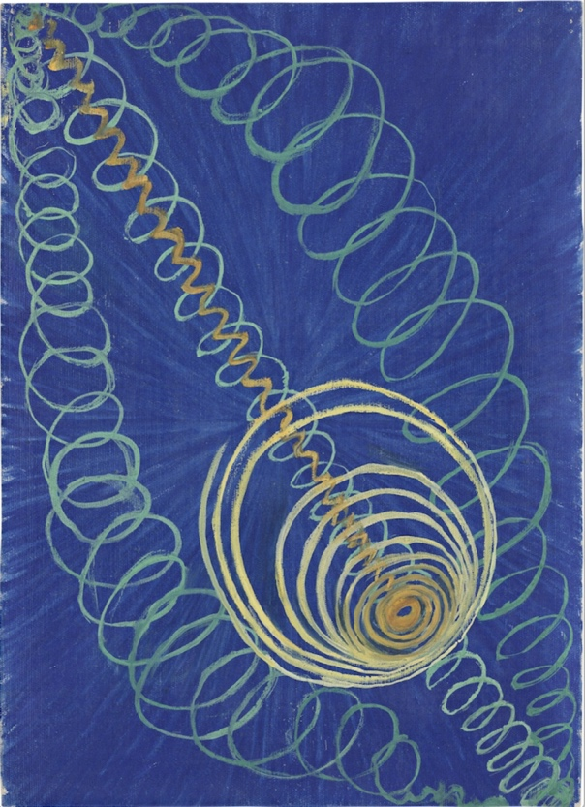
Painting by Hilma af Klint

Let nothing disturb you,
let nothing frighten you,
all things will pass away.
God never changes;
patience obtains all.
Whoever has God lacks nothing.
God alone suffices. Amen
—Teresa of Avila
First reading: from John Donne
I throw myself down in my chamber, and I call in, and invite God, and his Angels thither, and when they are there, I neglect God and his angels for the noise of a fly, for the rattling of a coach, for the whining of a door; I talk on in the same posture of praying, eyes lifted up, knees bowed down, as though I prayed to God; and if God or his angels should ask me when I thought last of God in that prayer, I cannot tell. Sometimes I find that I had forgot what I was about, but when I began to forget it I cannot tell. A memory of yesterday’s pleasures, a fear of tomorrow’s dangers, a straw under my knee, a noise in mine ear, a light in mine eye, an anything, a nothing, a fancy, a chimera in my brain troubles me in my prayer.
Music: Nocturne in C# Minor, by Frederic Chopin, performed by Bruce Liu
https://www.youtube.com/watch?v=s_ST3hzMsVE

Second reading: “Meditation’s Secret Ingredient” by Mark Epstein
Concentration is the secret ingredient of meditation, the backbone of the entire endeavor. It is the simplest, most elementary, most concrete, most practical, and most ancient therapeutic technique in the Buddhist repertoire. It is a means of temporarily dispelling the repetitive thoughts of the everyday mind, a way of opening the psyche to new and unscripted experiences […] Concentration is “right” when it connects with the other branches of the whole. It is “right” when it demonstrates the feasibility of training the mind, when it supports the investigation of impermanence, when it erodes selfish preoccupation, and when it reveals the benefits of surrender. It is not “right” when it is seen as an end in itself and when it is used to avoid painful truths.
…
Concentration is a channel into something we do not have exact words for. The unconscious? Mystery? The imagination? Love and light? It is tempting to turn whatever it is into something more concrete than we can actually apprehend.
Right concentration argues against doing this. I think that is why it is saved for the last step instead of being talked about at the beginning. Right concentration does not want us to get attached to it. It does not want us to turn it into an object of worship. Use it to free yourself, but don’t turn it into another thing. Allow it to remain unpredictable.
Music: Nocturne Op. in E minor, 72, No. 19, by Frederic Chopin, performed by Arthur Rubinstein
https://www.youtube.com/watch?v=S8e2h7Iu1NA

Time of Silent Contemplation
There is nothing I can give you which you have not;
But there is much, very much, that while I cannot give,
You can take.
No heaven can come to us unless our hearts find rest in it today.
Take heaven!
No peace lies in the future which is not hidden in this present instant.
Take peace!
The gloom of the world is but a shadow. Behind it, yet within our
Reach is joy.
Take joy!
There is a radiance and glory in the darkness, could we but see,
And to see we have only to look.
I beseech you to look!
Life is so generous a giver, but we, judging its gifts by the covering,
Cast them away as ugly, or heavy, or hard.
Remove the covering and you will find beneath it a living splendor,
Woven of love, by wisdom, with power.
Welcome it, grasp it, and you touch the angel's hand
That brings it to you.
Everything we call a trial, a sorrow, or a duty
Believe me, that angel's hand is there, the gift is there,
And the wonder of an overshadowing presence.
Our joys, too, be not content with them as joys.
They, too, conceal diviner gifts.
Life is so full of meaning and purpose,
So full of beauty beneath its covering—
That you will find earth but cloaks your heaven.
And so, at this time, I greet you.
Not quite as the world sends greetings,
But with profound esteem
And with the prayer that for you, now and forever,
The day breaks, and all the shadows flee away.
- Fra Giovanni, 1513 A.D.
Communal blessing:
What we see, Divine Presence, is the bee aiming its attention at the sunflower. And then a breeze moves the flower and the bee is without its focus. We also misdirect our focus on a moving universe. May our concentration be supple and forgiving. May the pressure of the outward gaze relax. The bee in its irregular orbits absorbs the nectar as the flower absorbs the bee. We offer our fleeting attention to the wholeness of a rapt and engrossed creation. Amen.
Music: Nocturne Op. 9, No. 3, by Frederic Chopin, performed by Maria Joao Pires
https://www.youtube.com/watch?v=RBlhCin5-fA

A blessing of focus, of being deeply immersed in the Divine current.

Yes, homecoming is this weekend!
And we will have delicious food!
And a photo booth~so be ready to put on your feather boa and strike a pose.
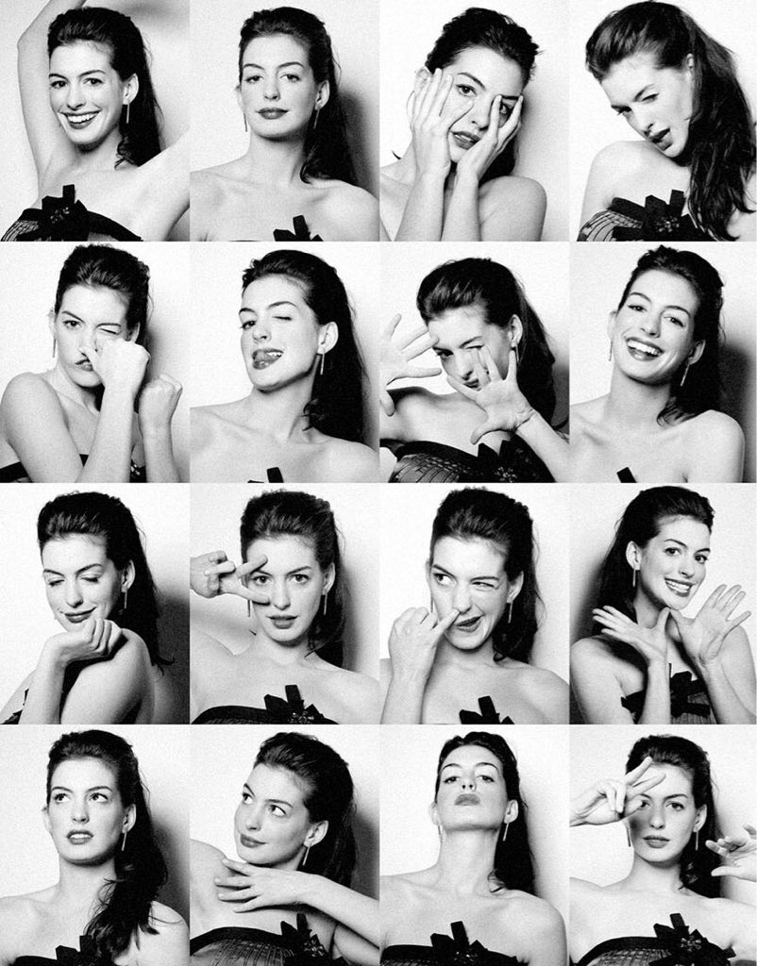
Okay, sadly, we do not expect Anne Hathaway to attend, but we want you!

And consider buying a book in support of the Prisoner’s Literature Project
as part of our Homecoming outreach.
https://www.amazon.com/hz/wishlist/ls/OZTZRXXUXKNI?ref_=wl_share

