Contemplative Service for Wednesday,
January 17, 2024

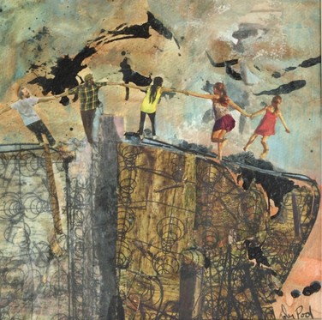
Art by Jim Rehlin

Life doesn't make any sense without interdependence. We need each other, and the sooner we learn that, the better for us all. —Erik Erikson

First reading: I Corinthians 12: 7, 11, 13-20
To each is given the manifestation of the Spirit for the common good.
All these are activated by one and the same Spirit, who allots to each one individually just as the Spirit chooses.
For in the one Spirit we were all baptized into one body—Jews or Greeks, slaves or free—and we were all made to drink of one Spirit.
Indeed, the body does not consist of one member but of many. If the foot would say, “Because I am not a hand, I do not belong to the body,” that would not make it any less a part of the body. And if the ear would say, “Because I am not an eye, I do not belong to the body,” that would not make it any less a part of the body. If the whole body were an eye, where would the hearing be? If the whole body were hearing, where would the sense of smell be? But as it is, God arranged the members in the body, each one of them, as he chose. If all were a single member, where would the body be? As it is, there are many members yet one body.

Music: “Dear Lord,” by John Coltrane
https://www.youtube.com/watch?v=FpoyOwKJ1A0&list=PLB3007FF98512F5B2&index=2

Second reading: from The Book of Joy: Lasting Happiness in a Changing World

When the Dalai Lama was asked what it was like to wake up with joy, he shared his experience of each morning: “I think if you are an intensely religious believer, as soon as you wake up, you thank God for another day. And you try to do God’s will. For a nontheist like myself, but who is a Buddhist, as soon as I wake up, I remember Buddha’s teaching: the importance of kindness and compassion, wishing something good for others, or at least to reduce their suffering. Then I remember that everything is interrelated, the teaching of interdependence. So then I set my intention for the day: that this day should be meaningful. Meaningful means, if possible, serve and help others. If not possible, then at least not to harm others. That’s a meaningful day.”

Music: “Cristo Redentor” by Don Byrd
https://www.youtube.com/watch?v=w2KvM2T40RQ&list=PLB3007FF98512F5B2&index=3

Time of Silent Contemplation
You are invited to 5-7 minutes of contemplative time.

Disturb us, O Lord
when we are too well-pleased with ourselves
when our dreams have come true because we dreamed too little,
because we sailed too close to the shore.
Disturb us, O Lord
when with the abundance of things we possess,
we have lost our thirst for the water of life
when, having fallen in love with time,
we have ceased to dream of eternity
and in our efforts to build a new earth,
we have allowed our vision of Heaven to grow dim.
Stir us, O Lord
to dare more boldly, to venture into wider seas
where storms show Thy mastery,
where losing sight of land, we shall find the stars.
In the name of the One who pushed back the horizons of our hopes
and invited the brave to follow.
Amen.
A prayer by Desmond Tutu, adapted from a prayer by Sir Francis Drake

Communal Blessing
Vast and Holy Energy,
We listen for the voice of each living thing. We listen for life in places we did not expect to find it. Your divine currents tune our ears to true and peculiar harmonies.
Each inflection is colored by, and responds to, another. We are rightly disturbed. We are truly brought to peace. May we join you in this moving, interacting, living current. Amen.

Music: “Clear Water,” by Meshell Ndegeocello
https://www.youtube.com/watch?v=oOJOVyKjWAI

May you find peace and meaning in the rhythms of creation in which we all live.

