Contemplative Service for Wednesday,
July 26, 2023

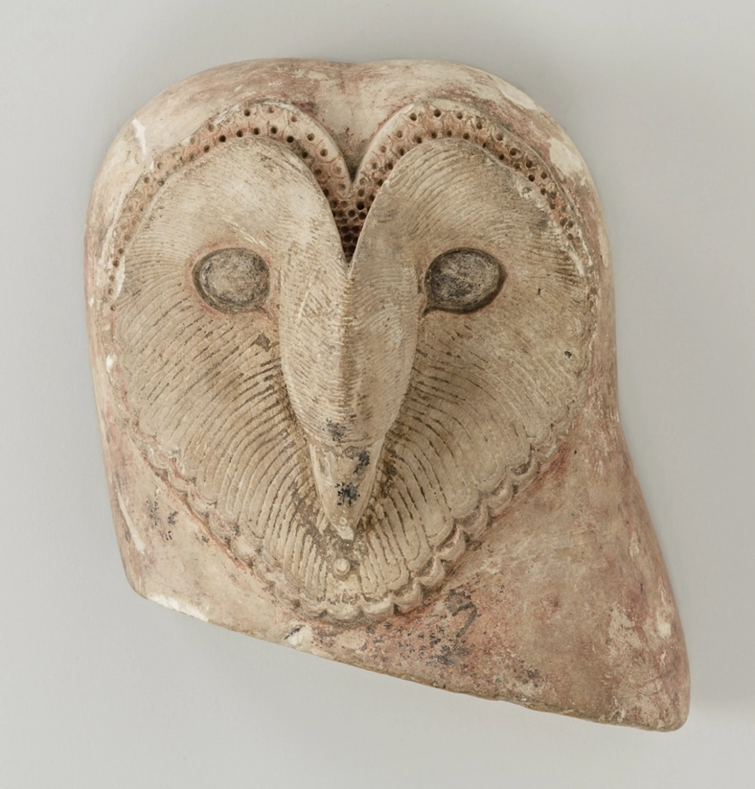
Ancient Egyptian sculpture
First reading: Proverbs 1: 2-7
For learning about wisdom and instruction,
for understanding words of insight,
or gaining instruction in wise dealing,
righteousness, justice, and equity;
to teach shrewdness to the simple,
knowledge and prudence to the young—
let the wise, too, hear and gain in learning
and the discerning acquire skill,
to understand a proverb and a figure,
the words of the wise and their riddles.
Respect for the Holy One is the beginning of wisdom.

Music: “My Mouth Will Speak Wisdom,” performed by Capella Romana
https://www.youtube.com/watch?v=2P5qZi2K9YM

Second reading: “Old Manuscript” by Alfred Kreymborg

The sky
is that beautiful old parchment
in which the sun
and the moon
keep their diary.
To read it all,
one must be a linguist
more learned than Father Wisdom;
and a visionary
more clairvoyant than Mother Dream.
But to feel it,
one must be an apostle:
one who is more than intimate
in having been, always,
the only confidant –
like the earth
or the sea.

Music: “The Wisdom Mantra” performed by Lama Surya Das and Steven Halpern
https://www.google.com/search?client=firefox-b-1-d&q=youtube.com%2C+wisdom+chants#fpstate=ive&vld=cid:42c66532,vid:kQhoWUjDYzA

Time of Silent Contemplation
We pray: Remove from us all self-deception; give us neither poverty nor riches; feed us only according to our daily need. Otherwise, we may be full, and arrogant and say "Who is the God after all?" or we shall be poor and steal in desperation. Keep us humble and mindful of your provision and of your mercy. You are the Giver of life and of all good things. All we have is yours. Amen.
--Adapted from Proverbs 30:8-9
Communal Blessing
Wisdom, we wait for you in your silence. In the unexpected shift that feels somehow completely natural. In your seriousness as in your irreverence. We lean on you, Wisdom, and you pour hardiness over us as a baptism. We hear your singing, distant and then near, as the night is anointed with dawn. Amen.

Music: “Chant to the Holy Angels,” by Hildegard of Bingen
https://www.youtube.com/watch?v=yjIAXI2xkEM

Go in peace. Walk in wisdom and compassion.

