Contemplative Service for Wednesday,
May 24, 2023
Pentecost
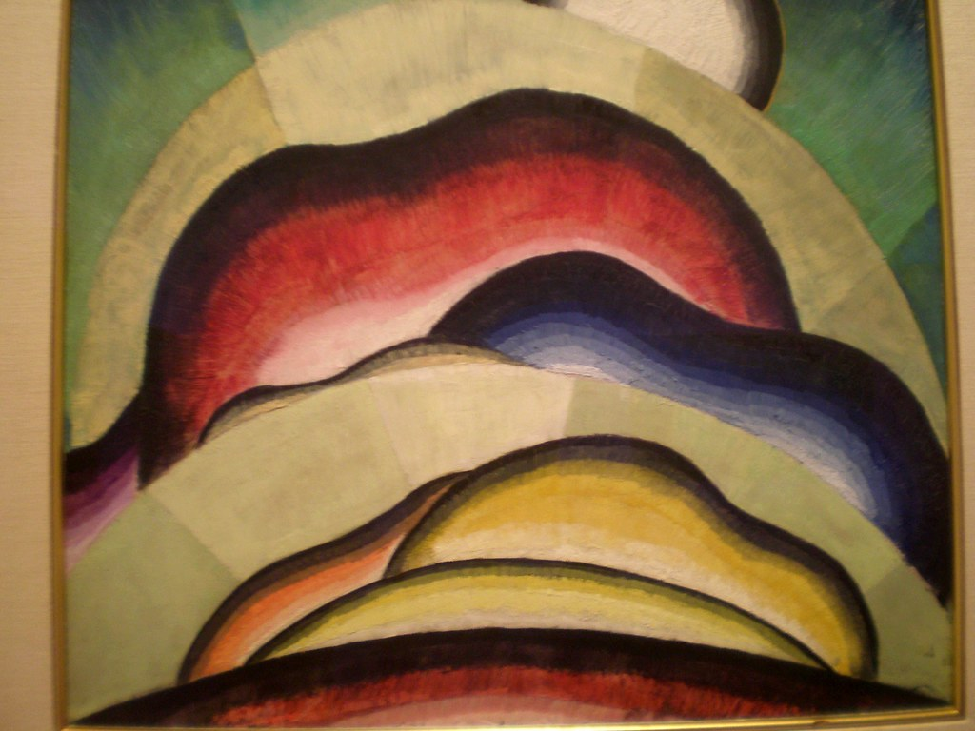

painting by Arthur Dove

You are called to be truly human, but it is nothing short of the life of God within you that enables you to be so, to be remade in God's image.
—N.T. Wright

First reading: Psalm 104: 24-30
O Creator, how manifold are your works! In wisdom you have made them all; the earth is full of your creatures. Yonder is the sea, great and wide, creeping things innumerable are there, living things both small and great. There go the ships, and Leviathan that you formed to sport in it. These all look to you to give them their food in due season; when you give to them, they gather it up; when you open your hand, they are filled with good things. When you hide your face, they are dismayed; when you take away their breath, they die and return to their dust. When you send forth your spirit, they are created; and you renew the face of the ground.

Music: Veni Creator, by Arvo Part
https://www.youtube.com/watch?v=RqLr1itXYvM
Second reading: “O Comforting Fire of Spirit,” by Hildegard of Bingen (1098–1179)
O comforting fire of Spirit,
Life, within the very Life of all Creation.
Holy you are in giving life to All.
Holy you are in anointing
those who are not whole;
Holy you are in cleansing
a festering wound.
O sacred breath,
O fire of love,
O sweetest taste in my breast
which fills my heart
with a fine aroma of virtues.
O most pure fountain
through whom it is known
that God has united strangers
and inquired after the lost.
O breastplate of life
and hope of uniting
all members as One,
O sword-belt of honor,
enfold those who offer blessing.
Care for those
who are imprisoned by the enemy
and dissolve the bonds of those
whom Divinity wishes to save.
O mightiest path which penetrates All,
from the height to every Earthly abyss,
you compose All, you unite All.
Through you clouds stream, ether flies,
stones gain moisture,
waters become streams,
and the earth exudes Life.
You always draw out knowledge,
bringing joy through Wisdom's inspiration.
Therefore, praise be to you
who are the sound of praise
and the greatest prize of Life,
who are hope and richest honor
bequeathing the reward of Light.
Music: Veni Creator Spiritus, by Palestrina
https://www.youtube.com/watch?v=OILk2uOjyJ8
Time of Silent Contemplation
O God, give us, we beseech Thee, in the name of Jesus Christ Thy Son our God, that love which can never cease, that will kindle our lamps but not extinguish them, that they may burn in us and enlighten others. Do Thou, O Christ, our dearest Savior, Thyself kindle our lamps, that they may evermore shine in Thy temple, that they may receive unquenchable light from Thee that will enlighten our darkness, and lessen the darkness of the world. Lord Jesus, we pray Thee give Thy light to our lamps, that in its light the most holy place may be revealed to us in which Thou dwellest as the Eternal Guide, that we may always behold Thee, desire Thee, look upon Thee in love, and long after Thee, for Thy sake. Amen.
—Columba

Communal blessing

Holy Traveler, you guide us on the way, your light warming the horizon. Your dawn shows us that each day is an arrival. Each thing we say in hope and confidence finds its own unison in other voices. By your presence we find ourselves anew in the comforting fire of the spirit. We are pilgrims arriving to you, with you, for you. Amen.

Music: Veni Sancte Spiritus, sung by Donna Stewart
https://mignarda.bandcamp.com/track/veni-sancte-spiritus-sequence-for-pentecost

