Contemplative Service for Wednesday
June 21, 2023

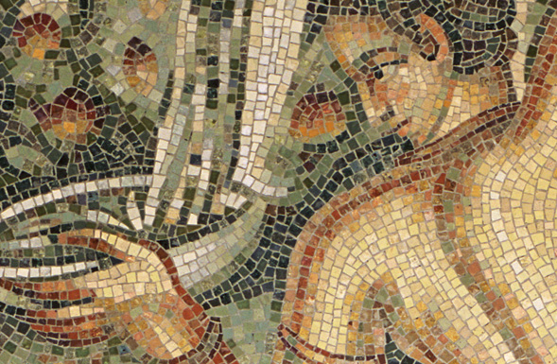

from a Roman mosaic

First reading: I Corinthians 15:51

Behold, I will tell you a mystery; we will not all sleep, but we all will be changed, in a moment, in the twinkling of an eye.

Music: “Seek Yourself in Me,” by Darlene Franz
https://wisdomchant.bandcamp.com/track/seek-yourself-in-me-trio-verison

Second reading: “The Book” by Kazim Ali

Before I came into the air from my mother,
I breathed her water.

Below any temple steps, there is always a beggar
who having renounced the world, seeks forms of direction.

Blind sometimes, or in ecstasy,
the book has become not a book.

Sometimes I wake up starving.
It is hard to know when to eat.

The page, square cover, sewn edge, table edge,
my weak sense of direction, collapsing to smoke.

When I wake like this, when neither the dream nor the day
have ruptured themselves into belief, the book unbuckles

and I think all of life is by faith only, that we are never delivered
from original water, that we are all a single equation

that approaches the axis, never arrives.

Music: “Unknowing, Abide” by Darlene Franz
https://wisdomchant.bandcamp.com/track/unknowing-abide

Time of Silent Contemplation

Soul, you must seek yourself in Me
And Me you must seek in yourself.
You were created for love
Beautiful, gracious, and thus
In my heart painted
Should you lose yourself, O my beloved,
Soul, you must seek yourself in Me.
But if perhaps you should not know
Where you may find Me
Do not go hither and thither,
But, if you should wish to find Me,
Me you must seek in yourself.
—St. Teresa of Avila (tr. Raimon Panikkar)

Communal Blessing
Elemental One, you come to us by every sense and every perception: a breath that opens, the vital water that quenches and bathes. We lose ourselves in you. Afloat on faith,
we navigate your infinite horizon. Buoyant in your mysterious word, we approach and meet unendingly. Amen.

Music: “Become all Flame” by Darlene Franz
https://wisdomchant.bandcamp.com/track/become-all-flame

Faith and peace be with you.

